**Question 1:** Streams…

**Answer:**

Result of streams command after it was first run:

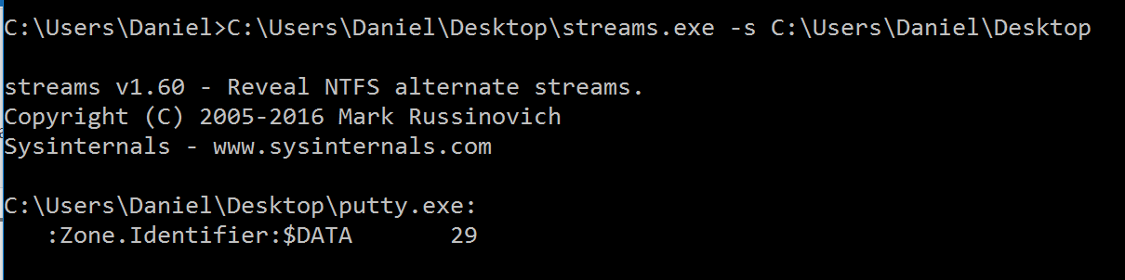

Embedding exe file into a .mp3 file:

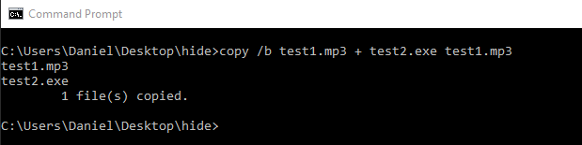

Result of streams command after it was run again:

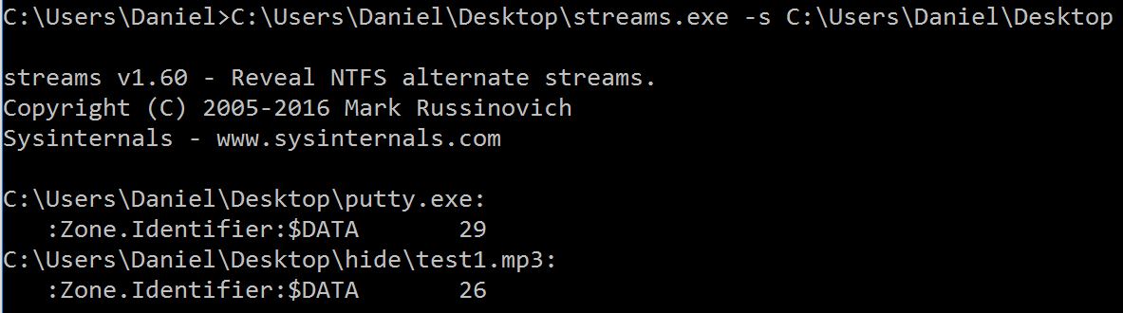

The second time the stream command was run, it found the second data stream that had previously not existed until after I had created it by hiding one file in another.